**3.2 Causal Deep Learning**

ZhaoZhi Qian (@QianZhaoZhi) & Jeroen Berrevoets (@J_Berrevoets)

**Research Pillar: Causal deep learning**

<https://www.vanderschaar-lab.com/causal-deep-learning/>

**Causality: the study of cause and effect**

* Philosophical schools for causality
  + Structural equations framework (Pearl)
    - <https://ftp.cs.ucla.edu/pub/stat_ser/r370.pdf>
  + Potential outcomes framework (Rubin)
    - <https://www.causalconversations.com/post/po-introduction/>
  + Probabilistic causation (Reichenbach)
    - <https://plato.stanford.edu/entries/causation-probabilistic/#:~:text=Reichenbach%20says%20that%20the%20common,result%20from%20a%20causal%20relationship>.
  + Counterfactual theory (Lewis)
    - <https://plato.stanford.edu/entries/causation-counterfactual/#:~:text=1.-,Lewis's%201973%20Counterfactual%20Analysis,would%20have%20happened%20without%20it>.
  + …
* **Application of causality: current state**

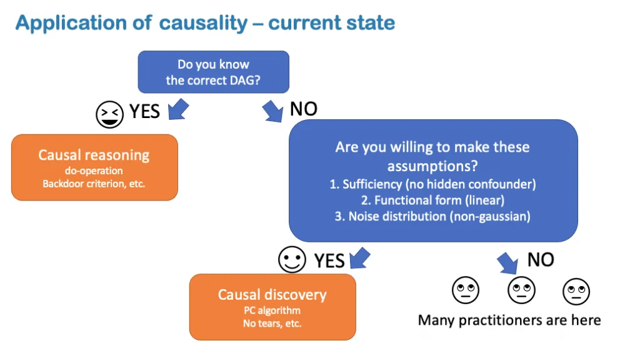

* + Bayesian network:
    - A connecting B: Causality
  + Estimating conditional probability
    - We do not know most of the correct DAG
      * No knowledge
    - Too many variables
      * Invisible
  + Automated causal discovery
    - Stringent assumptions
      * Sufficiency (no hidden confounder)
      * Functional form (linear)
      * Noise distribution (non-gaussian)
    - Thus, for most practitioners, casual theory cannot be applied
      * Causal deep learning

**What is casual deep learning?**

* Ladder causation
  + Association:
    - Deep learning methods
    - Powerful and expressive
    - Unable to generalization
  + Interventions
    - Lot of rooms between intervention and association
      * Casual Deep Learning may hello
        + E.g. improving **association** robustness -> domain generationlisation -> to motivate **correct** objectives -> to **intervention**
    - Mostly causality
    - Principled, but many assumptions
    - e.g. Clinical trials
  + Counterfactual

**Causal deep learning**

* Use tools and concepts from causality to inform deep learning
  + Loss function, regularization
  + Inductive bias, architecture design
  + Auxiliary task, self-supervision
  + Theoretical foundation and formalism
* Focus on empirically verifiable tasks and metrics
  + Real data validation
  + Quantitative model comparison
  + Iterative model development
  + Beyond one-dataset-one-task setting
    - Different environments (demographics, geographical locations)
    - Different actions (variation in practice)
    - Different tasks (multiple endpoints, labels)

**How can we CDL?**

* Moving up the ladder
  + Improving association (CASTLE)
  + Domain generalization (CAS)
  + Correct goal definition (MCM)
  + Interventions (DECAF)
* Preliminaries on graphs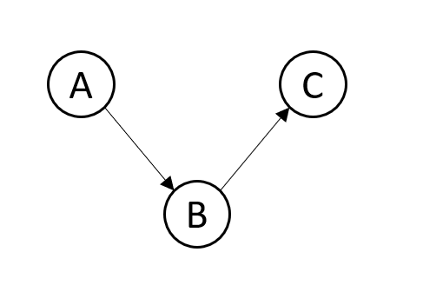
  + Considering bayesian network (Pearl)
    - Causal structure,
    - A can impact B and then C
  + Some properties:
    - Resembles p(A,B,C) but much more compact
    - A does not give us information on C once we know BL
      * A ⟘ C | B
  + When the network is causal, this happens:
    - Knowing this graph, can mutilate it by intervening on a variable
    - Observe a new distribution pdo(B:=b)(A,B,C)
  + BNs gives structure, causal graphs gives knowledge – both can be used
* Association using structures (BNs)
  + Using structuring to improve supervised learning?
    - Regularization
      * L2 makes sure the weights of a model are small
      * L1 encourages sparse weights
    - Only one-size-fits all solutions – smarter solution:
      * Just like L1 and L2, adda differentiable regularizer to a loss function:
        + *tr(eAoA) - d*
      * Which is 0 when A is DAG
        + <https://papers.nips.cc/paper/2018/hash/e347c51419ffb23ca3fd5050202f9c3d-Abstract.html>
        + http://proceedings.mlr.press/v108/zheng20a/zheng20a.pdf

**Association using structure (BNs)**

* CASTLE
  + **CASTLE: Regularization via Auxiliary Causal Graph Discovery**
  + <https://arxiv.org/pdf/2009.13180.pdf>
* Set A to be based on the input layers of a neural network
* With DAG,incorporate the regulariser as a reconstruction based regulariser which only reconstructs adjacent features

**Domain generalization using causal graphs**

* CAS
* Causal structure should remain constant over domains
  + Exploiting:
    - Given a DAG (learned or assumed), learn a model in the training domain, respecting that DAG
    - Model then at an advantage in the target domain – same DAG governing
* **Improving Model Robustness Using Causal Knowledge**
  + <https://arxiv.org/abs/1911.12441>
* **Exploiting Causal Structure for Robust Model Selection in Unsupervised Domain Adaptation**
  + <https://ieeexplore.ieee.org/document/9503312>

**Defining correct goals using causal graphs**

* MCM
* Imputing missing data when estimating treatment effects:
  + Missing data may cause treatment selection – Z→
    - Transfusing blood if blood type is not measured
    - Decide to transfuse Type O
  + treatment may cause missingness →Z
    - Many treatment decisions require blood test to be performed
    - Much less likely when not getting that treatment
  + Consider a binary vector Z ∊ {0,1}d indicating when a variable in X is missing, then above realization leads to two factors in Z
  + Using graphical models, recognise some structure in missingness

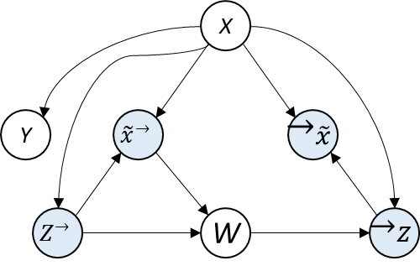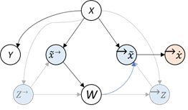

* + - Transformation of structure
      * X is moving directly to X out into W
      * X→ : should not impute
      * →X: should impute
      * Collateral structure, no influence of →X
        + Only conditioning will influence
    - Because of the structure, conditioning on entire covariate set, either imputed or not imputed, introduces bias in the model
      * **To Impute or not to Impute? Missing Data in Treatment Effect Estimation**
        + <https://arxiv.org/abs/2202.02096>

**Using interventions to generate fair data ~DECAF**

* Interventions to change a distribution;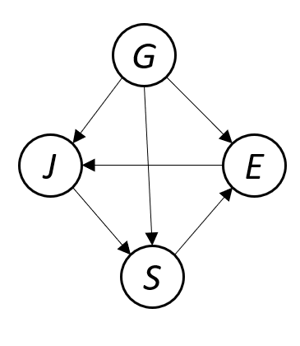
  + Distribution:
  + *G* = gender
  + *E* = education
  + *J* = job
  + *S* = salary
* Why is gender influencing salary?
  + Dataset including the variables in the graphical model
  + DECAF: propose method mitigate the issue
    - **DECAF: Generating Fair Synthetic Data Using Causally-Aware Generative Networks**
      * <https://arxiv.org/abs/2110.12884>

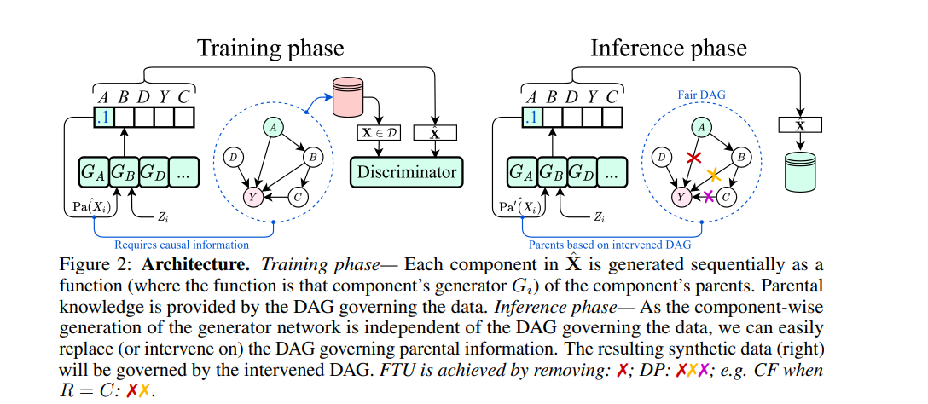

* DEAF trains a generative model for each feature
  + Respecting the topological order of a causal graph
    - Input and output
  + At inference phase, can simply intervene on the graph and sample new data that respects the new graph

**Summary**

| Using causality we can generate synthetic fair data for downstream models | **DECAF generates fair data** from intervened causal graphs | ▲ | | | Using **interventions** |
| --- | --- | --- | --- |
| Causality can yield new insights into architecture and learning objectives | **Causal structure dictates** what to impute and what not to impute | ▲ | | | Motivating **correct** objectives |
| DAGs remain constant across domains | **CAS** and other methods exploit this to **enhance generalization** | ▲ | | | Domain generalization |
| Discussed how we can use causality to regularize | **CASTLE regularizes** the hypothesis space with auxiliary DAG discovery | ▲ | | | Improving **association** |

**Q&A**

* Temporal data to the model
  + In short terms, recurrent neural structure – be cautious
  + Needs to be dealt separately in a longer term
    - Causality in a time series is submitting
* Data size matters?
  + Larger sample sizes with assumptions favoring
  + Proper causal analysis with larger size will allow higher confidence
  + Causal DL analysis should be fine with small sample size
* GAN:
  + Allowing new regularization function in computation itself
  + Enforcing the theorem
  + Using some sort of invitation that enforces independence between treatment and imputed values